# CS 255 System Design Document

## UML Diagrams

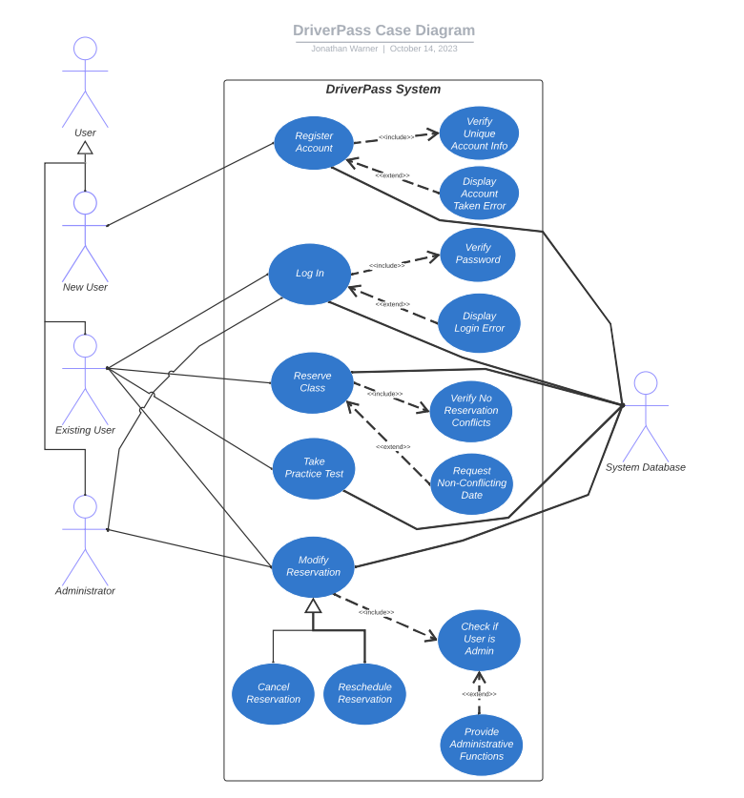

### UML Use Case Diagram

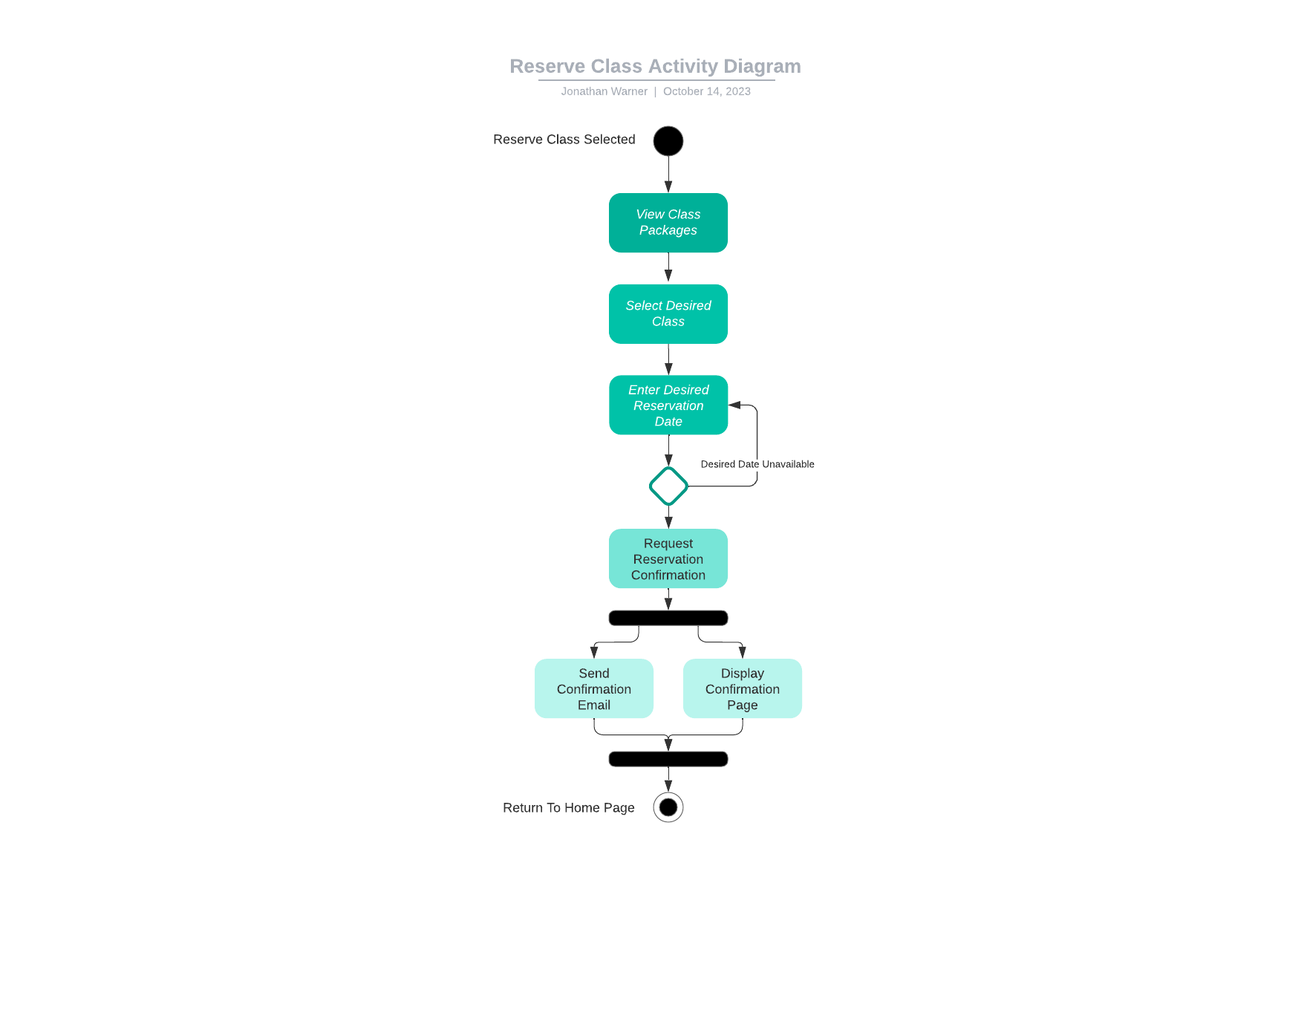

### UML Activity Diagrams

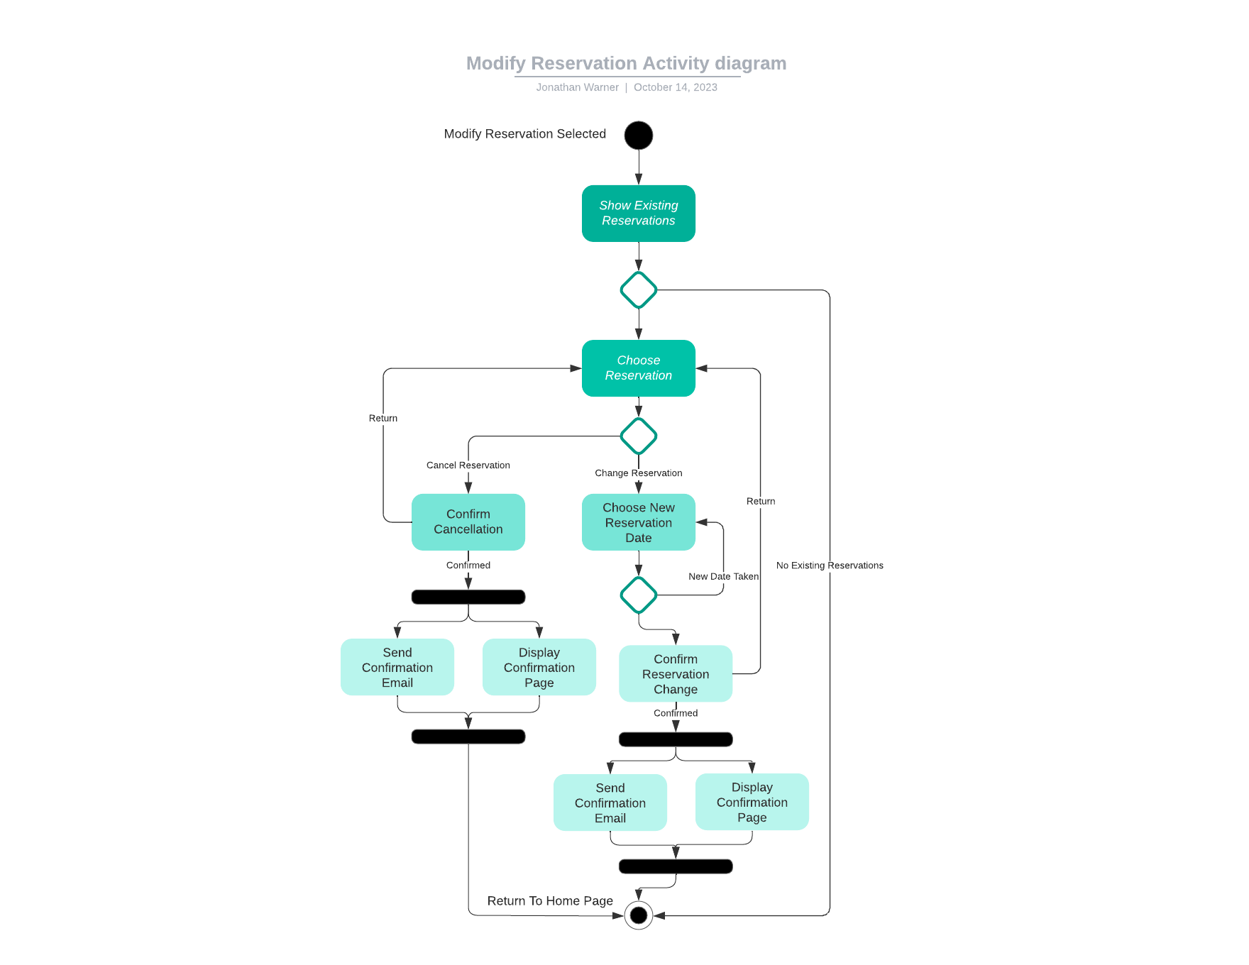

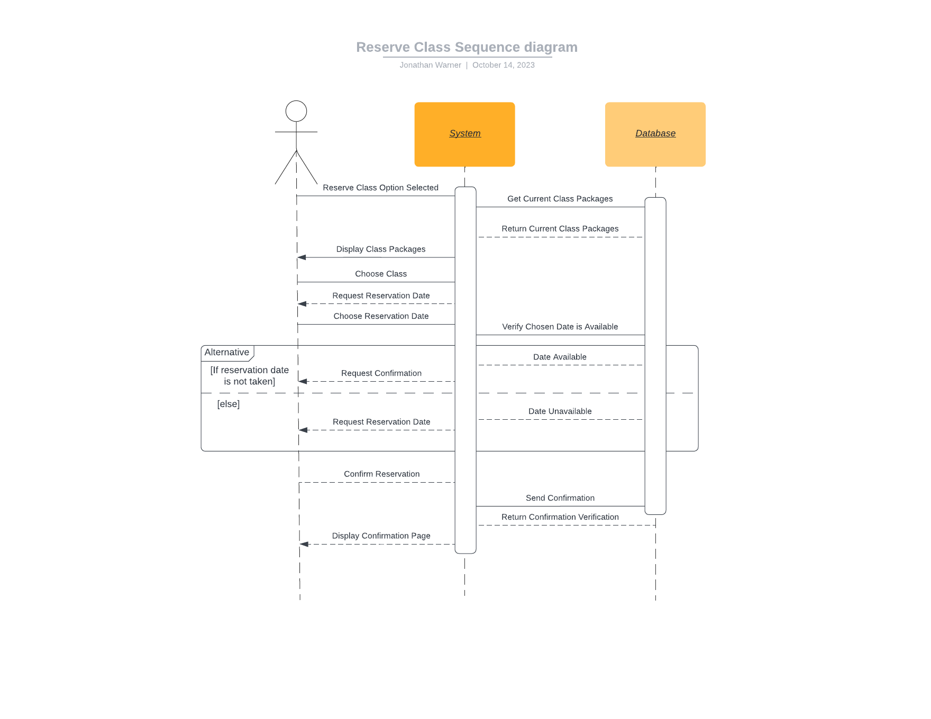

### UML Sequence Diagram

### UML Class Diagram

## Technical Requirements

1. ***Hardware***-**Database Server:** The system will need to utilize a database through an online access point, which can be used to store both system and user data.   
   -**Backup Server:** To ensure redundancy and safeguard user data, a backup server will need to be employed.
2. ***Software*-Operating System:** The DriverPass system should be hosted and running on a server operating system, such as Windows Server.  
   **-Database:** Data will need to be stored and managed efficiently through the use of a relational database management system, such as MySQL.
3. ***Tools*-Backup and Recovery:** Software to run and manage the backing up and recovery of the DriverPass system will be necessary to use the backup server.

**-Version Control:** The use of a version control system like Git can help increase collaboration within the development team and easily track changes within the code.   
**-Monitoring and Logging:** Tools that enable the ability to track and record different system or account events will be essential for administrative and diagnostic purposes.

1. ***Infrastructure*****-Security:** Protecting both user and server data is crucial when operating a web-based system, and as such, the use of a security protocol like TLS or SSL will be necessary.   
   **-Load Balancing:** The system should implement load balancing to handle times of high traffic and prevent a reduction in availability.  
   *­***-Power Interruptions:** The use of an uninterruptible power supply, or UPS, for the host system would prevent power loss from interrupting service to users.